**Adjusting Agricultural Practices in Response to Environmental Change**

* + **Climate Resilient Agriculture**

**Team Members:**

1. Xiaomao Lin, Associate Professor, Kansas State University, 785-761-6160, [xlin@ksu.edu](mailto:xlin@ksu.edu)
2. Kraig Roozeboom, Professor, Kansas State University, 785-565-3909, kraig@ksu.edu
3. Deann Presley, Associate Professor, Kansas State University, 785-313-4193, [deann@ksu.edu](mailto:deann@ksu.edu)
4. Robert Aiken, Associate Professor, Kansas State University, 785-443-0092, [raiken@ksu.edu](mailto:raiken@ksu.edu)
5. Zachary Zambreski, Graduate Research Assistant, Kansas State University, 817-975-5059, [ztz@ksu.edu](mailto:ztz@ksu.edu)
6. Yuxin He, Assistant Professor, Sichuan University, Cell: 13688002125, [yuxinhe@scu.edu.cn](mailto:yuxinhe@scu.edu.cn)

**Dates of Visit:** August 18, 2017 – September 1, 2017

**Summary:**

Our objectives for this exchange were to: 1) exchange knowledge on the impacts of environmental changes on crop production and on practices and climate-informed tools that are being developed to increase cropping system resilience with a specific focus on corn, soybean, and wheat production systems; and 2) explore collaborative priorities and mechanisms for ongoing U.S.-China cooperation on challenges to production of these crops presented by environmental changes and development of ag-climate risk monitoring tools through integrating soil health, water and nutrient management, crop modeling, and climate information. Scientific exchange was conducted with Faculty and Administrators of three Agricultural Universities and Scientists of the Chinese Academy of Agricultural Science. Our team learned of the complex structure of Chinese Agriculture, ranging from highly mechanized and high-yielding National Farms to intensive intercropping practiced by extensive small-holders. Indeed, the increased land productivity of intercropping presents an opportunity for U.S. Agriculture. A warming climate is driving an expansion of triple- and double-cropping systems further north, while increasing uncertainty of timely precipitation. Opportunities to build on this SCEP include Memoranda of Understanding between KSU and Chinese Universities supporting short-term student and faculty visits, undergraduate and graduate training programs, and research collaboration in drought monitoring and mitigation, yield gap analysis, intercropping opportunities, and soil management.

**I. Overview and Expectations**

Emerging insights from adaptive agricultural management and climate-smart agriculture suggest that building agricultural resilience to face environmental change is a sustainable path addressing food security challenges related to environmental change and variability. Our objectives for this project were to: (1) exchange knowledge on the impacts of environmental changes on crop production and on practices and climate-informed tools that are being developed to increase cropping system resilience with a specific focus on corn, soybean, and wheat production systems; and (2) explore collaborative priorities and mechanisms for ongoing U.S.-China cooperation on challenges to production of these crops presented by environmental changes and development of ag-climate risk monitoring tools through integrating soil health, water and nutrient management, crop modeling, and climate information.

**II. Description of the Program in China**

Our presentation included an overview of major Innovation Labs hosted by the K-State College of Agriculture; recent evidence of climate change and impacts in the U.S. Great Plains; effects of water limitations on productivity of wheat and new approaches to identify varieties with enhanced water productivity; tillage impacts on soil erodibility and benefits of cover crops for soil protection, nutrient management, and improving cropping system resilience.

Highlights of information we gained from discussions and field trips include appreciation for the contribution of intensive management for high-yielding maize, soybean, and sorghum production managed by the National Farms in northeast China; the challenge of labor productivity in intensive small-holder cropping systems; opportunities to increase land productivity with relay and intercropping techniques in southwest China; recognition of the expansion of triple-cropping and double-cropping systems towards the north of China; and use of simulation techniques to quantify yield gaps and their interactions with climate change.

Key institutions contacted included China Agricultural University (CAU), Sichuan Agricultural University (SCAU), Chinese Academy of Agricultural Sciences (CAAS), and Bayi Agricultural University (BYAU). Major points discussed included opportunities for student and faculty short-term visits, undergraduate and graduate training programs, and joint-research activities in intercropping and climate-adapted crop cultivars and cropping practices. Schedule of meetings is provided in Table 1.

Near-term collaboration with the CAU Agro-meteorology program included discussion of algorithms for calculating drought indices (Lin) and on-going collaboration in wheat yield modeling (Aiken). The US team identified opportunities for further collaboration with the CAU Agro-meteorology program, including analysis of geographic shifts in US cropping systems related to climate change (Roozeboom; already analyzed in China). Dr. Yang at CAU identified analyzing yield gaps in US and China, identifying limiting factors that contribute to yield gaps, and differences in wheat productivity in US and China as potential topics for future collaboration.

Benefits for U.S. agriculture include improved understanding of potential cropping system adjustments to climate change, opportunity to increase land productivity through novel intercropping practices, and to gain understanding of cold tolerance in grain sorghum cultivars and cropping practices.

**Table 1**: Detailed visiting activities

|  |  |  |
| --- | --- | --- |
| **Date/Place** | **Time** | **Activities** |
| **Daqing, Heilongjiang** |  |  |
| August 21, Monday | Morning | Daqing Planning Museum,  Natural History Museum |
| Afternoon | Bayi Agricultural University  Adjusting agricultural practices in response to environmental change—Resilient Agriculture |
| August 22, Tuesday | Noon | National Farm Banquet |
| Afternoon | National Farm Tour |
| **Beijing** |  |  |
| August 24 | Afternoon | China Academy of Agricultural Sciences  Adjusting agricultural practices in response to environmental change—Resilient Agriculture  Discussion of information support for high-yield production systems |
| August 25 | Morning | China Agricultural University  Workshop on Adjusting agricultural practices in response to environmental change—Resilient Agriculture |
| Afternoon | China Agricultural University  Discussion with Faculty and Students from Department of Meteorology Program |
| **Chengdu, Sichuan** |  |  |
| August 28, Monday | Morning | Sichuan Agricultural University  Adjusting agricultural practices in response to environmental change—Resilient Agriculture  Research Progress of maize-Soybean Intercropping System |
| Afternoon | Field Visit of Renshou County Experimental Site |
| August 29, Tuesday | Morning | Dujiangyan Irrigation System |

**III. Outcomes and Accomplishments**

The Agro-meteorology group of CAU has combined use of crop modeling and historical crop productivity observations to analyze relationships of climate variability and changes and crop yield gaps (a metric of potential yield gains). Their findings show that the northern limits of multiple cropping systems have been shifted northward, resulting in a 2.2% increase in national production of three major crops. The KSU team recognizes and has discussed strong potential for collaboration with CAU faculty and students to apply these methods to US cropping systems.

The advantages of strip and relay inter-cropping, utilized in intensive small-holder systems, have been recognized for decades[1] including up to a 50% increase in land productivity. The faculty of SCAU have developed advances in production methods and knowledge related to increased productivity. The main innovation in their intercropping system is that the distance between two adjacent maize rows is shrunk and the wide strip between two narrow strips is expanded, improving light use efficiency for both crops. Combined with optimal cultivar screening and an increase in planting density, this system increases maize yield while also obtaining additional soybean production. Challenges to adoption in mechanized agriculture include machinery design, pest management, and development of adapted cultivars. The potential to increase land productivity in water-sufficient regions can motivate joint collaboration in this research area.

The KSU team has initiated conversations with KSU administrators regarding opportunities for international collaboration. KSU currently has MOU with CAU and CAAS; our KSU team will review these agreements and evaluate value in discussing revisions with our CAU and CAAS counterparts. Our team recommends pursuing MOU with SCAU, BYAU and HBAU to facilitate short-term student and faculty visits; undergraduate and graduate training programs; and joint research collaboration in drought monitoring and mitigation, yield gap analysis, intercropping opportunities and soil management.

The KSU team is preparing audio-visual presentations for our departments and colleges, as well as printed material suitable for newsletters of our professional societies. Dr. Zheng of BYAU is among the scientists we visited who is planning to travel to the US for scientific meetings in January, 2018 as well as possible visit at KSU.

**IV. Lessons Learned and Recommendations**

The leadership of Dr. Lin was instrumental in structuring this visit as well as facilitating follow-up. His familiarity with Chinese scientists and institutions was critical. Hospitality of China MOA and our local hosts was superb. We appreciate the opportunities to learn of accomplishments and challenges to agriculture in China.

**V. Contacts**

**China Agricultural University, Beijing**

Dr. Jiang Rongfeng, Associate Dean of College of Resources and Environment; Director of Quzhou Experiment Station; Deputy Director of Center for Resources, Environment and Food Security

Dr. Yang Xiaoguang, Professor of Agro-meteorology

Dr. Feng Liping, Director of System Modeling and Software Technology Lab; Deputy head of Department of Agrometeorology

Dr. Gong Yuanshi, Vice President of China Agricultural University.

**Chinese Academy of Agricultural Sciences, Beijing**

Dr. Li Maosong, Director of the Lab of Agro-disaster monitoring and risk reduction, Institute of Agricultural Resources and Regional Planning

Dr. Zhang Bin, Soil Biophysics, CARS Soil Expert for Soybean

Professor Luo Xinlan, Deparment of Applied Meteorology, Shenyang Agricultural University

**Sichuan Agricultural University, Chengdu, Sichuan.**

Prof. Yang Wenyu, Vice President of Sichuan Agricultural University

Dr. Wang Xiaochun, Professor, Department of Agronomy

**Bayi Agricultural University. Daqing, Heilongjiang.**

Dr. Zhang Changqing, Director of Foreign Affairs Office

Dr. Zheng Dianfeng, Professor and Dean, National Grain Engineering Technology Center

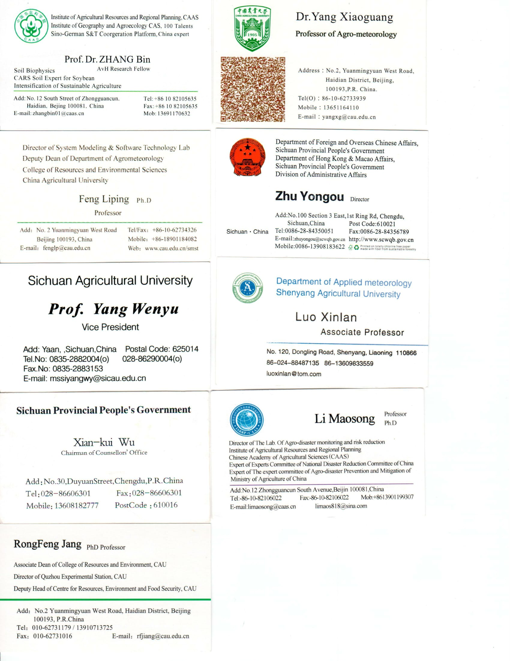

**VI. Additional Information**

The following is additional summary information about particular topics of our trip.

*Climate change in Great Plains, USA*

An overview of climate change in the Great Plains was given by PhD student Zach Zambreski. He highlighted the spatially variable nature of climate change for this region. For example, the eastern Great Plains has seen a significant increase in precipitation since 1901 while little significant change has occurred across the High Plains. Although the number of drought events has been decreased, the frequency of intense drought events has increased in the last thirty-seven years. Variability in mean growing season precipitation and temperature for winter wheat and corn has changed since 1901, most notably in the northern plains for winter season temperature and southeast plains for precipitation due to the increase in wet events driving large differences. The occurrence of flash drought has statistically increased since 1980 in Kansas during April and May, which are months that are typically critical for winter wheat development. Furthermore, non-irrigated yield variability has changed since 1970 for state-level analysis in Texas, Kansas, and Nebraska with notable changes in variance occurring during the late 1980s. The change in year-to-year variability can be driven by a variety agronomic and climate factors including but not limited to an increase in climatic variability, changes in crop selection and management practices (e.g. soils, row spacing), and the responses of genetics to these factors. The evidence to support these hypothesis is still lacking, and we posed this question of yield variability/stability during our visits in order to hopefully form a collaboration effort on this subject.

*Climate change in China*

At CAU in the department of agricultural meteorology, the three main research areas in climate change are cropping system adaptations, agro-climate disasters, and agriculture system modeling. The evidence of climate change in China that was presented by graduate students at China Agricultural University was compelling. Overall, China has shown an overall tendency of changing towards a warmer and drier climate state. There are areas of China that have become wetter, including the middle and lower Yangtze River, South China, and Northwest China. Weather stations north of Beijing have seen the greatest increases in temperature between 0.29 and 0.79 °C decade-1, indicative of a similar trend seen in most of northern states in the Great Plains. The two questions presented in multiple presentations were: how does climate change affect crop yields in China and what are the yield gaps between on-farm and potential yields and will climate change affect the yield gaps in China? Based on research presented, northern limits of multiple cropping systems have been shifted northward, resulting in a 2.2% increase in national production of three major crops. The northward expansion of maize in northeast China has led to increase in maize yield when hybrids were switched.

*Connecting faculty and students with farmers*

Closing the knowledge gap between farmers and academic institutions is prioritized in China. University extension programs do a good job alleviating this disconnect through engagement with farmers (e.g. workshops). China Agricultural University takes this a step further. They send approximately 80 students to live in villages across China for one to two years. The goal is to transfer knowledge from university to farmer, engender positive relationships, and broaden student horizons. The state of Kansas could benefit from this kind of interaction between farmers and university students even if only for one or two weekends in one year. In addition, faculty also openly interact with farmers through “wechat”, answering questions farmers may have about management, pests, or disease.

**VII. Attachments**

* Results from Pre- and post-questionnaire that we conducted.

**VIII. Photos**

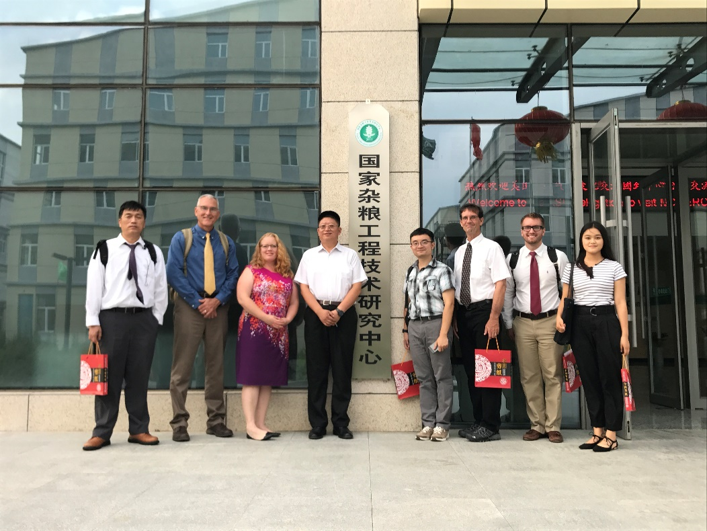

**Fig. 1:** KSU SCEP team and Dr. Zheng after discussions at the National Coarse Grain Center.

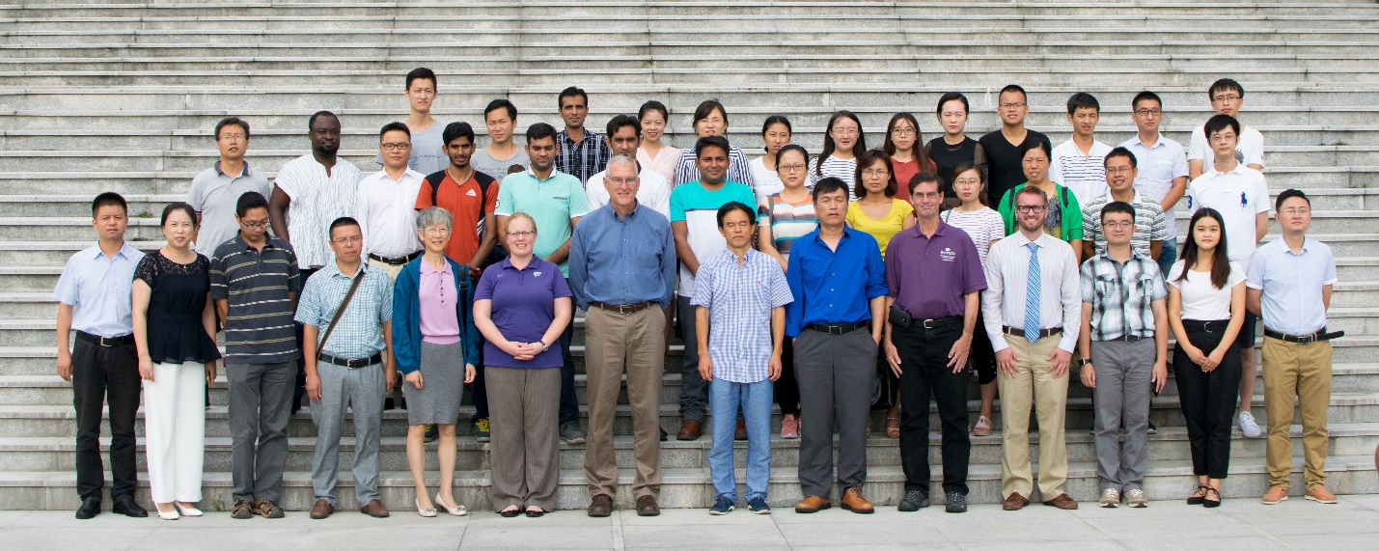

**Fig. 2:** KSU SCEP team and Sichuan Agricultural University faculty and graduate students.

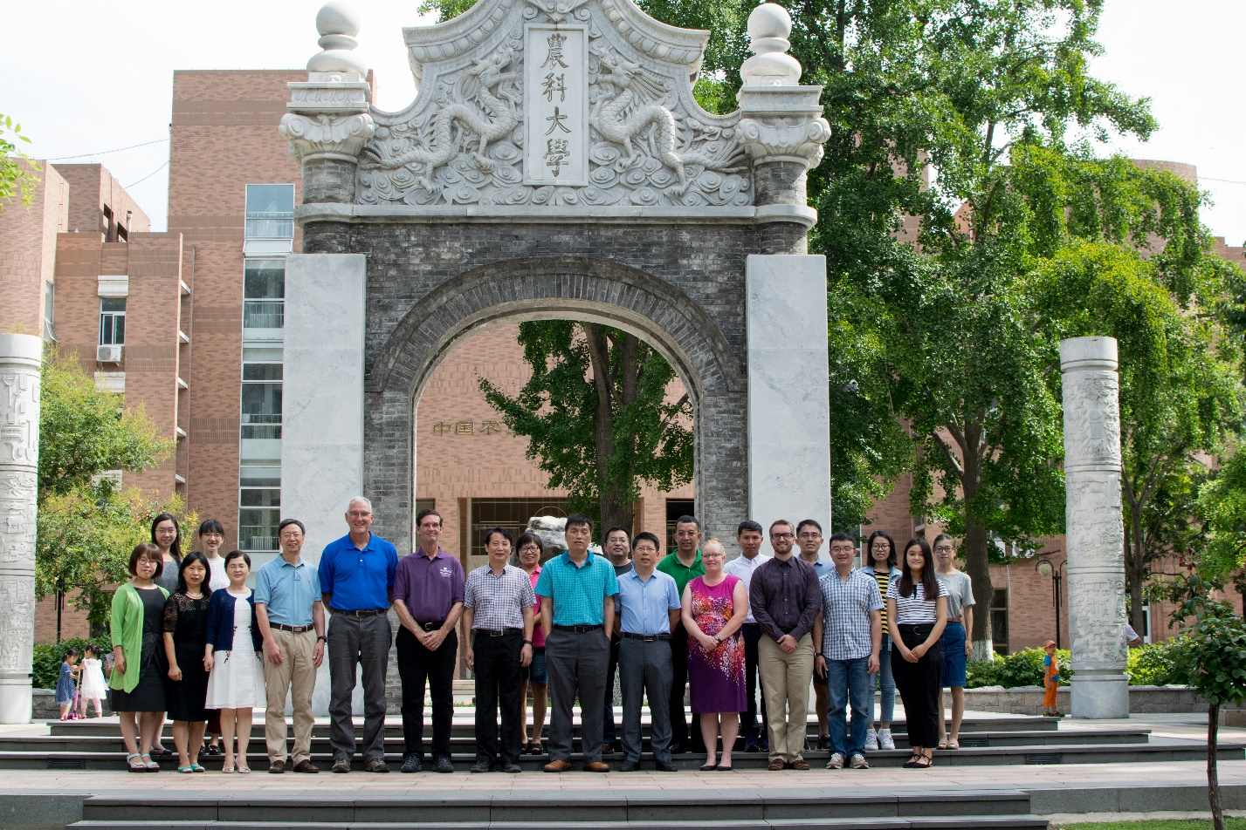

**Fig. 3:** KSU SCEP team and administration, faculty, and graduate students at China Agricultural University.

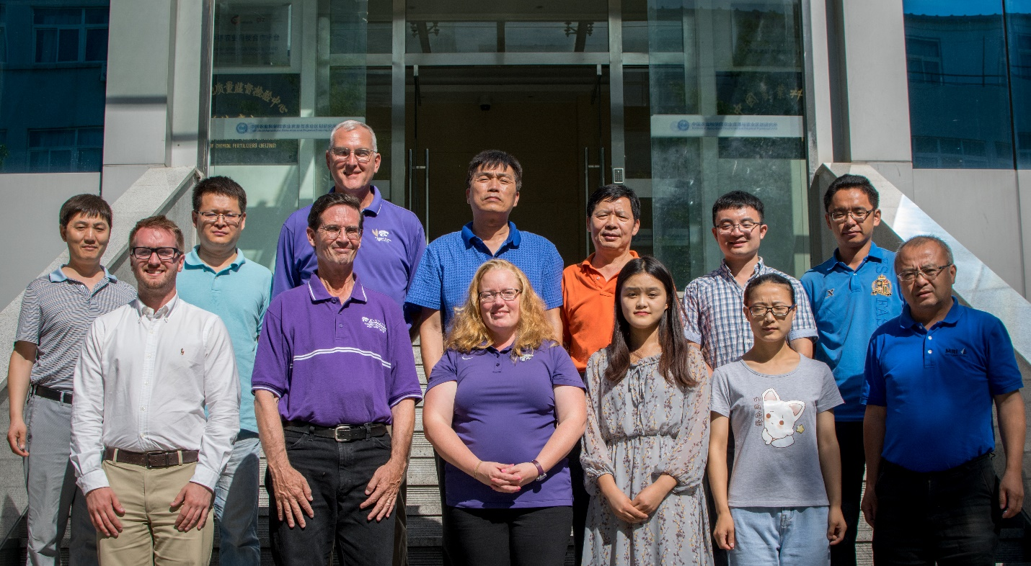

**Fig. 4:** KSU SCEP team and faculty at the Chinese Academy of Agricultural Sciences.

1. Francis, C.A. 1986. Introduction: Distribution and importance of multiple cropping. In C.A. Francis (ed.) Multiple cropping systems. Macmillan Publ. Co., New York.